30 N. 4th Street  Easton, PA 18042

484-546-4230  FAX: 610-829-6076  www.eaaecs.org

**Easton Arts Academy Elementary Charter School**

**Fifth Grade Supply List**

Dear 5th Grade Families,

We have an exhilarating year ahead of us! As you know, students at Easton Arts Academy Elementary Charter School are involved in a program that is both academically rigorous and immersed in the arts. To facilitate this program to the best of our ability, we respectfully request each fifth grader come to school with the necessary tools to make their experience successful. These supplies include:

Individual Student Supply List:

* Six Folders (one per each classroom subject, plus two to be shared among their ARTS classes)
* Notebook
* Pencils
* Colored Pencils
* Crayons
* Safety Scissors (rounded top)
* Glue Stick
* Pencil box
* Headphones* - Please place these in a Ziploc bag with your student’s name on it.
* 8.5”x11” Sketchbook – To remain at school for art class.

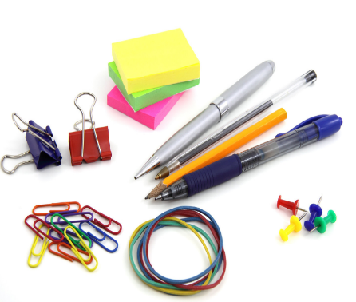

[This Photo](https://mommysnippets.com/save-school-supplies/) by Unknown Author is licensed under [CC BY-NC-ND](https://creativecommons.org/licenses/by-nc-nd/3.0/)

***The information contained in this transmission may contain privileged and confidential information, including student information protected by federal and state privacy laws. It is intended only for the use of the person(s) named above. If you are not the intended recipient, you are hereby notified that any review, dissemination, distribution, or duplication of this communication is strictly prohibited. If you are not the intended recipient, please contact the sender by reply email and destroy all copies of the original message.***