30 N. 4th Street  Easton, PA 18042

484-546-4230  FAX: 610-829-6076  www.eaaecs.org

**Easton Arts Academy Elementary Charter School**

**Fourth Grade Supply List 2022-2023**

* Water Bottle (preferably not metal)
* 1 pair of safety scissors
* 1 Pencil case/box
* 1 pack of standard/mechanical pencils
* Erasers
* 2 highlighters (1 yellow & 1 their choice)
* 1 box of markers
* 2 dry erase markers
* 1 box of crayons
* 1 box of colored pencils
* 2 Glue sticks
* Ruler
* **Headphones/earbuds** (to be kept at school) – labeled in a plastic bag (these do not need to be expensive)
* **1 ½ inch, 3 ring binder OR trapper-keeper (zips closed)**
* 6 pocket folders with hole punches to be in a binder (5 Star works best and last longer)
  + 1 green (Science)
  + 1 yellow (ELA)
  + 1 blue (Math)
  + 1 orange (Social Studies)
  + 1 red (Homework)
  + 1 purple (Morning Work)
  + 1 color or pattern of choice (personal folder)
  + 3 Composition book
  + 1 spiral notebook

**Please make sure all materials are labeled with students’ first and last name.**

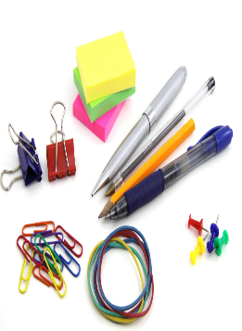

[This Photo](https://mommysnippets.com/save-school-supplies/) by Unknown Author is licensed under [CC BY-NC-ND](https://creativecommons.org/licenses/by-nc-nd/3.0/)

CLASSROOM COMMUNITY SUPPLIES

* Tissues
* Hand sanitizer
* Paper towels
* Lysol/Clorox wipes
* Ziploc bags (any size gallon, sandwich, quart)
* Pencils
* Lined paper
* Any art supplies
* Tape (scotch, masking, duck tape…)

Thank you all for preparing your child for the upcoming Fourth Grade School Year!!!

We are all looking forward to a Fantastic Fourth Grade Year!

***The information contained in this transmission may contain privileged and confidential information, including student information protected by federal and state privacy laws. It is intended only for the use of the person(s) named above. If you are not the intended recipient, you are hereby notified that any review, dissemination, distribution, or duplication of this communication is strictly prohibited. If you are not the intended recipient, please contact the sender by reply email and destroy all copies of the original message.***